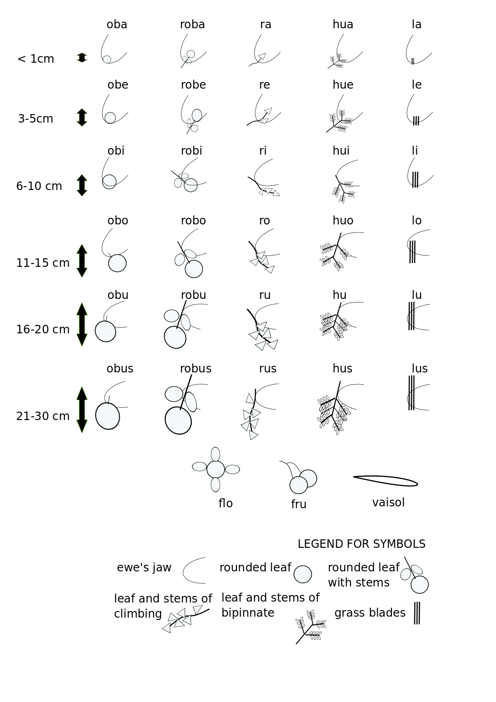
Figure 1. Bites categories (BC) adapted to the deciduous tropical forest vegetation. The codes used during the observation are given above the icons. The length of removed materials is indicated in cm (left of the chart). The BC from left to right (columns 1 to 5) were: (1) when bites included single rounded or oblong leaves (herbs, woody shrubs, trees, and climbers or creepers); (2) the same plants when bites included more than one leaf and a portion of the stem or branch; (3) when bites included climbers and creeper plants with leaves and vines; (4) when bites included woody plants of bipinnate leaves (with steam, leaves, and branches); and (5) when bites included leaves and stems of grass, as well as of herbs of straight, elongated thin leaves. The codes “flo” and “fru” were used to identify the harvest of flowers and fruits, and the code “vai-sol” was used for the fallen pods consumed from the ground. The last three codes could be used as single BC or in addition to the other codes when the bite also included some of these structures.

